Flowchart and Notes Two

Michael Surdek
Southern New Hampshire University
DAT 690: Capstone in Data Analytics
Professor Arman Kanooni
September 18, 2022
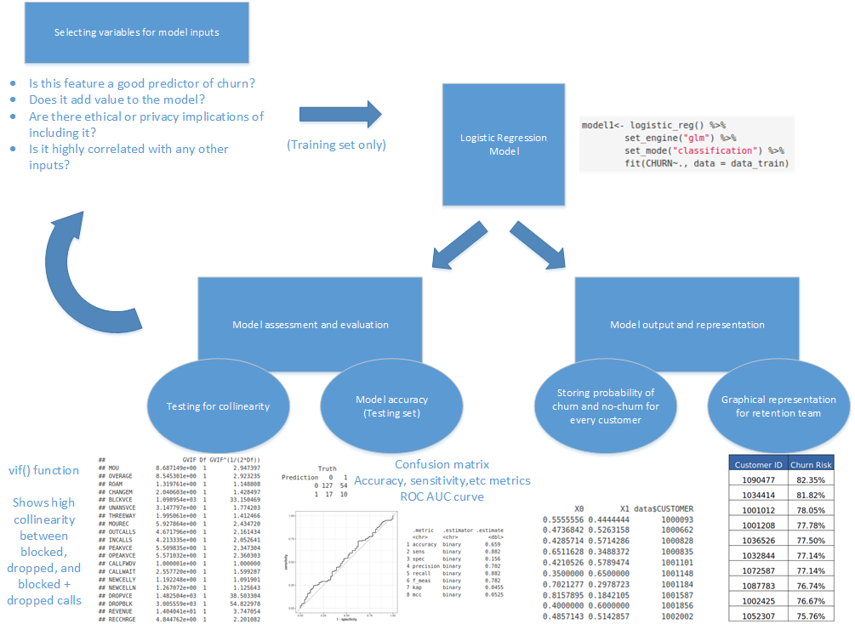
The model building process involves iterative steps between selecting input variables, choosing and training the model, testing for collinearity, assessing the model’s performance, storing it’s output, and graphically representing information to the end user. This flowchart describes the considerations for selecting variables including whether they are good predictors of churn and if they are highly correlated with each other. These are important the first time the model is built, but even more so after evaluating the performance and other aspects of different versions of the model. One method for identifying variables that are highly correlated is to measure the collinearity of each variable in the model. VIF, or the variance inflation factor, is a measure of how much a variable depends on the others that are included. Although a high VIF has no impact on the actual predictions, it throws of the interpretability of the variable’s coefficient and makes it more difficult to interpret the model’s results. Handling variables with high VIF values requires returning to the data preparation and input selection phase in order to choose one of the variables individually or combine them into one feature.
Once variable interactions and collinearity are addressed, the model can be evaluated in different ways, such as confusion matrix, simple metrics such as sensitivity and specificty, or with an ROC AUC curve. Each measure of evaluation should be interpreted according to the baseline target defined by the specific problem. In this case, we are shooting for an 70% accuracy on brand new customer data. Additionally, missing customers who end up cancelling is more harmful than identifying a satisfied customer as likely to churn. Therefore, the number of false positives and negatives should be considered as well.
Lastly, a predictive model is only as useful as it is applicable to a real world problem. For this reason, it is important to storing the results of the model each time it is scored on new customers and to have the ability to convert that information into a visual format for the end user. The main output of the model is the probability that any customer will or will not churn. This can easily be combined with the customer’s ID number in order to know who is who. Also, it would make sense to store the date that the prediction was made, which would be easy to do each time. Finally, the retention team is mostly interested in the customers with the highest chance of cancelling. For that reason, the stored data can be sorted according to the likelihood that they will churn. Then, a certain number of customers or all customers above a certain likelihood threshold can be passed to the retention team in a basic table that gives the customerID, their likelihood to churn, and personal information such as their email or phone number. Finally, a well-developed model could even provide the main reasons why the model believes the customer is likely to churn.

